Project AIS – AI Based Search for Vendor Transaction Data.

1. Problem Statement
Project AIS aims to solve the challenge of efficiently retrieving and analysing contract-related information from a database. Organizations often struggle with managing vendor contracts, invoices, purchase orders, and financial records, leading to inefficiencies in contract management and financial tracking. The project provides an intelligent system to query and retrieve contract details using natural language processing. As a Vendor Manager or Business owner, connecting to a database querying the transaction data is tedious, or opening an SAAS based application, applying multiple filter to extract simple information is time challenging.

2. Objective
The primary objective of Project AIS is to develop an AI-driven contract intelligence system that allows users to query contract-related data using natural language. The system should:
- Enable efficient contract and invoice retrieval.
- Provide accurate financial insights.
- Reduce manual effort in contract analysis.
- Enhance decision-making with structured data outputs.

3. Approach
The approach taken for Project AIS involves:
- Database Structuring – Organizing contract data into an SQLite database.
- Natural Language Processing – Using LlamaIndex for querying structured data.
- AI-Powered Query Handling – Leveraging OpenAI’s GPT models to process user queries.
- Data Indexing and Retrieval – Structuring contract information for faster access.
- Response Synthesis – Generating meaningful, structured responses from raw database results.

4. Technical Overview
Technology Stack:
- Programming Language: Python
- Database: SQLite
- AI Model: LlamaIndex, OpenAI GPT-3.5 Turbo
- Libraries & Frameworks:
  - SQLAlchemy (Database ORM)
  - LlamaIndex (NLP Query Processing)
  - Pandas (Data Handling)
  - FastAPI (for API-based interaction, if applicable)

5. System Design
The system follows a modular design:
- Database Layer: Stores contract, invoice, and vendor information.
- Query Processing Layer: Handles user queries and translates them into structured SQL queries.
- AI Model Layer: Uses LlamaIndex and OpenAI GPT for interpretation.
- Response Handler: Formats and synthesizes the response for the end user.
Data Flow:
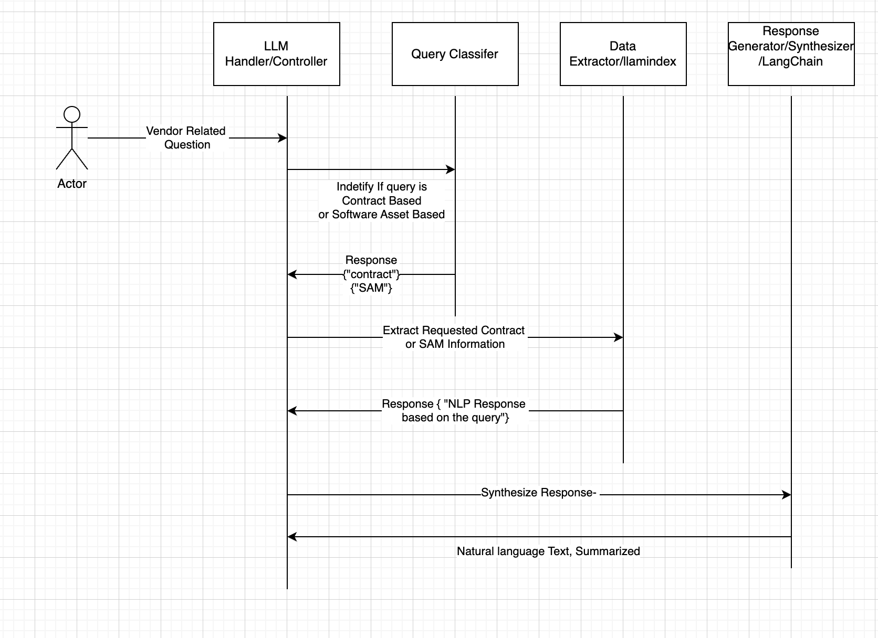

- User enters a query in natural language.
- Query is classified into different types (e.g., total contract value, invoice details, active contracts, etc.).
- The relevant SQL query is generated and executed on the SQLite database.
- Results are fetched and structured into an AI-generated response.
- The response is displayed to the user.

Core Components

1. LLM Handler
The LLM Handler serves as the interface between user queries and the language model. It processes incoming queries, determines their intent, and interacts with the appropriate components (such as the Query Classifier and Data Extractor). It formats the query correctly before sending it to the LLM and handles the response formatting before returning it to the user. Since Llama Index is used for database queries, the LLM Handler no longer needs to extract vendor names separately.

2. Query Classifier
The Query Classifier determines the category of a given user query by leveraging sentence embeddings and similarity matching. It pre-stores embeddings of predefined query categories (e.g., "contract," "software," and "other") in Redis for quick retrieval. When a new query arrives, the classifier computes its embedding, compares it with stored embeddings, and assigns the best-matching category. This improves query routing efficiency and reduces unnecessary calls to downstream systems.

3. Data Extractor (Llama Index)
The Data Extractor uses Llama Index to fetch structured data from an SQL database based on natural language queries. It connects to the SQLite database, ensures the required tables (like contracts) exist, and creates an index for efficient querying. Unlike traditional SQL queries, Llama Index allows users to retrieve relevant information using conversational search without manually writing SQL. To improve efficiency, Llama Index should ideally be preloaded rather than being initialized for every query.

4. Response Synthesizer
The Response Synthesizer takes structured information retrieved from Llama Index (or other sources) and converts it into a user-friendly response. It ensures that the final response is clear, contextual, and formatted properly. In cases where information is missing, the synthesizer can request additional clarifications or guide the user to refine their question. This step enhances the usability of responses and provides a seamless conversational experience.

Implementation Details
The project structure consists of the following modules:

1. Database Module (db/):
- ais.db – SQLite database containing contract data.
- db_conn.py – Handles database connection.
- db_create_contract_data.py – Creates tables and schema.
- fetch_contract_details.py – Fetches relevant contract data.
- insert_sample_data.py – Seeds the database with sample contract records.

2. LLM Processing Module (llm/):
- llama_contract_index.py – Creates and maintains the LlamaIndex structure.
- llm_handler.py – Handles interaction between queries and the AI model.
- query_classifier.py & query_classifier2.py – Classifies user queries into predefined categories.
- response_synthesizer.py – Converts raw query results into meaningful responses.
- vendor_name_extractor.py – Identifies vendor names from user queries.

3. Utility Module (utils/):
- config.py – Stores configuration settings.

4. Main Execution File:
- main.py – Entry point to run the project and interact with the system.

8. Test Results
The system has been tested for different contract-related queries, including:
- General Vendor Information: Successfully retrieves vendor details.
- Active Contracts: Filters and fetches ongoing contracts.
- Invoices Paid Till Now: Returns total invoice payments made.
- Number of Purchase Orders: Counts PO records associated with a vendor.
- Total Contract Value: Aggregates the total contract amount.
- Active Contract Value: Filters and calculates the total active contract value.
Test cases verified that the system provides accurate and timely responses.

9. Next Steps
Future improvements for Project AIS include:
- Enhancing NLP Accuracy: Fine-tuning AI models for better query understanding.
- Expanding Database Coverage: Adding more contract metadata.
- Integrating with External APIs: Connecting with ERP and finance tools.
- Implementing a Web UI: Providing a frontend for user interaction.
- Optimizing Query Performance: Using caching and indexing techniques.

